Drawing Steps for One Point Perspective

Use these step-by-step directions to learn how to make a realistic drawing that shows “perspective.”


Perspective is “the art of drawing solid objects on a two-dimensional surface so as to give the right impression of their height, width, depth, and position in relation to each other when viewed from a particular point.”
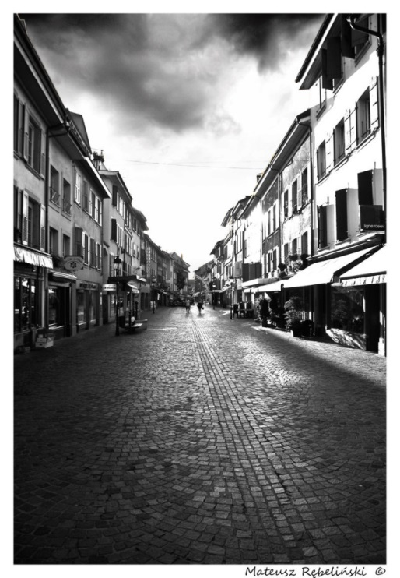



1. Draw a line horizontally through the middle of the paper like you see here: this is the horizon line
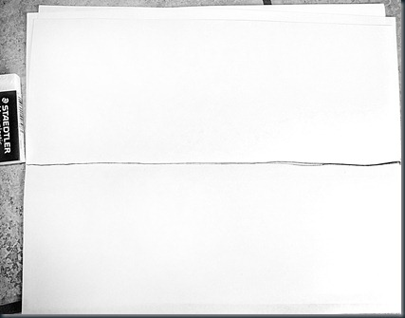

2. Draw a dot in the middle (vanishing point) and make an “X” from corner to corner (or close enough) passing through the dot
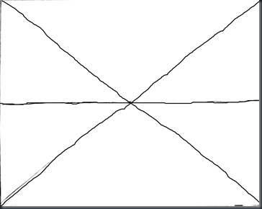

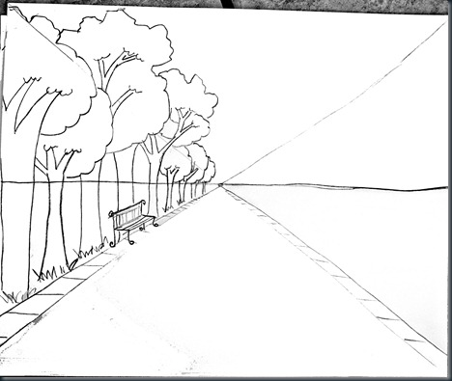
3. Draw the sidewalks first from the vanishing point
4. Draw the trees starting on the bottom on the “X” all the way to the vanishing point, descending towards the middle. Draw organic shaped trees, not round Q-tip lollypop trees! Make sure the trees are straight and parallel to the side of the paper. You don’t want to spend 20 minutes drawing 8 beautiful but very leaning trees and have to erase all of them!

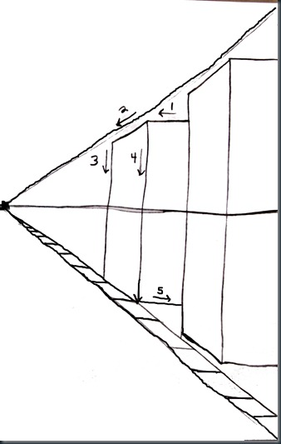
5. This is the lingo I use to teach the buildings, Say, “One, straight out, two diagonal down, three, straight down to the ground, four straight down again, and five, bring it in along the side!”

6.
The lines on the tops and bottoms of the windows ABOVE the horizon line are parallel to the top part of the “X”…….below that, when you PASS the Horizon line, the lines on the tops and bottoms of the windows are parallel to the BOTTOM part of the “X” which is now the sidewalk. The top of the door is also parallel to the sidewalk.
The windows on the OTHER side of the house are normal right angle squares or rectangles.
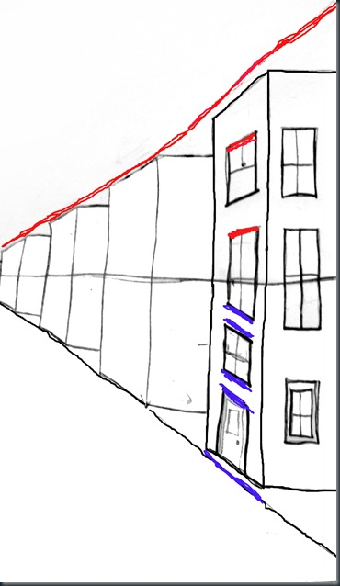
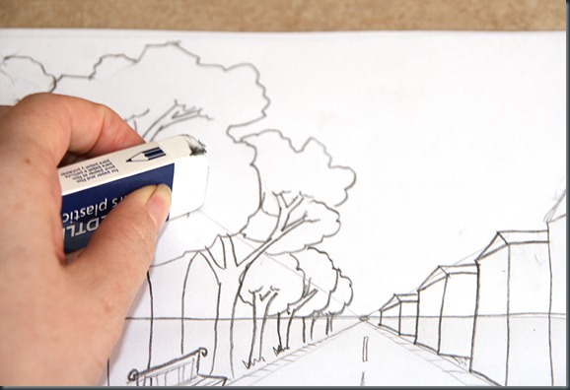
7. Now erase the “X” and the parts of the horizon line that overlap the trees and buildings

8. Finish windows and add details. You can make it into a river instead of a road. Now that the basic foundation is drawn, the possibilities for creativity are ENDLESS!!
Cars, trucks, planes, restaurants, people, bridges, parades, parks, pedestrians, lights, etc, etc
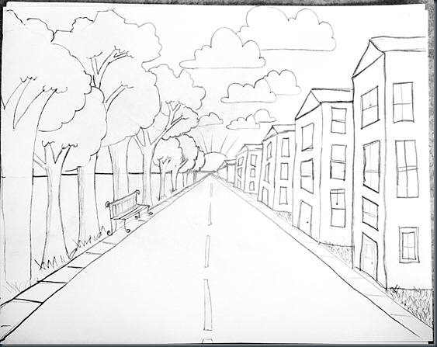
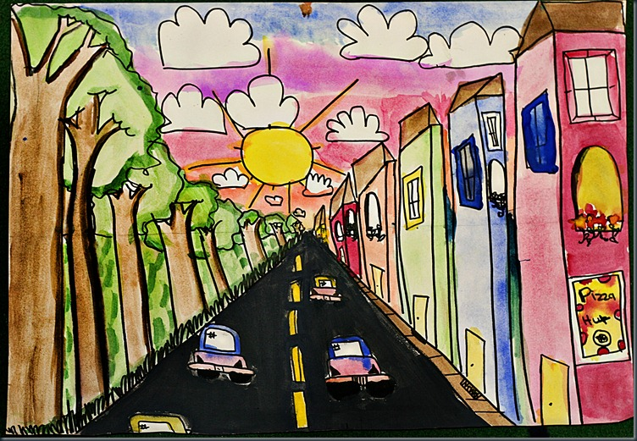
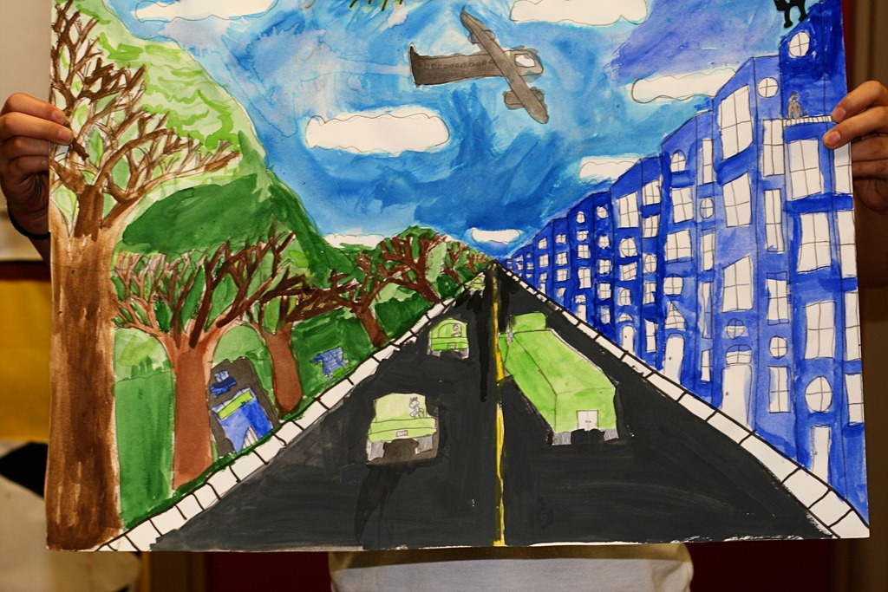
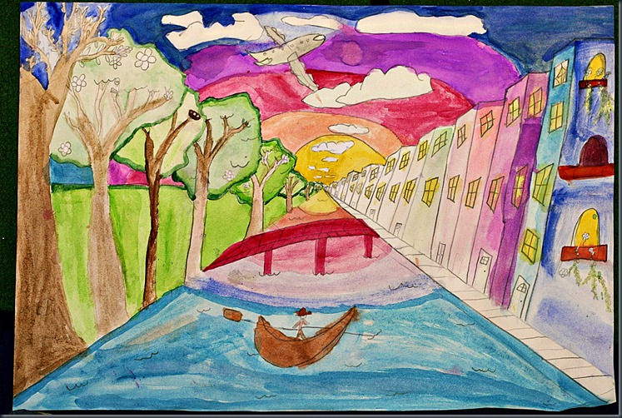

Check out this post for additional examples:
http://www.elementaryartfun.blogspot.com/search/label/One%20Point%20Perspective

