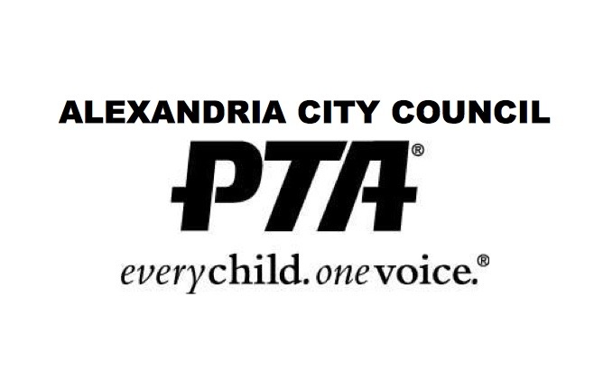
Alexandria PTA Council Officer Nomination Application
Please complete the form below to indicate your interest in serving as an officer on the Executive Board of the Alexandria PTA Council for the 2022-2023 school year. The Nominations Committee will vote on a slate of officers on April 18 and present the slate to the full PTA Council on April 20 for their review. The election will take place on May 20 and nominees will be notified shortly thereafter of the results. If you have questions, contact Missy Estabrook, Nominations Committee Chairman, at President.elect@alexvaptac.org.
Nominee: ___________________________________________________________________________
Email: ______________________________________________________________________________
Phone: _____________________________________________________________________________
Current PTA Member of (Name of School):__________________________________________________
Please select the position you are seeking:
1st Vice President of Outreach
Vice President of Programs
Treasurer
In the event that there are multiple candidates for your desired position, would you be willing to consider another PTAC Board role for the 2022-2023 term? If so, please write it in below.
________________________________________________________________________________________________________________________________________________________________________
Please share why you would like to serve in this role, the related skills and expertise you would bring to PTAC, and how your PTA experience to date supports this position.
________________________________________________________________________________________________________________________________________________________________________________________________________________________________________________________________________________________________________________________________________________________________________________________________________________________________________________________________________________________________________________________
What would you personally like to accomplish as a PTAC Board member?
________________________________________________________________________________________________________________________________________________________________________________________________________________________________________________________________________________________________________________________________________________________________________________________________________________________________________________________________________________________________________________________
Thank you for your interest in serving on PTAC! It is because of volunteers like you that the Alexandria PTA Council can support underserved communities and seek to create equity among the units. By initialing below, you acknowledge that you give consent to be nominated and agree with the PTAC mission to make every child’s potential a reality by engaging and empowering families and communities to advocate for all children.
____________________________________________________________________________________

